Aircraft Design 1 – Fall 2025

Assignment 2: Preliminary & Propulsion Sizing

Student Names and USCIDs:

Aurelio Santiago, C30461119

Mateo Garcia, V02125756

Jacob Chin, C96554174

Instance 1

Hours spent on assignment: 1h

Aircraft type: Business Jet

Aircraft number: 110

Table 1: Requirements Table

|  |  |  |
| --- | --- | --- |
| Requirement Type | Value | Unit |
| Payload | 1100 | Kg |
| Range | 3600 | km |
| Cruise Altitude |  | m |
| Cruise Speed | 830 | km/hr |
| Take-off Distance | 1200 | m |
| Landing Distance | 860 | m |
| Propulsion System | jet |  |

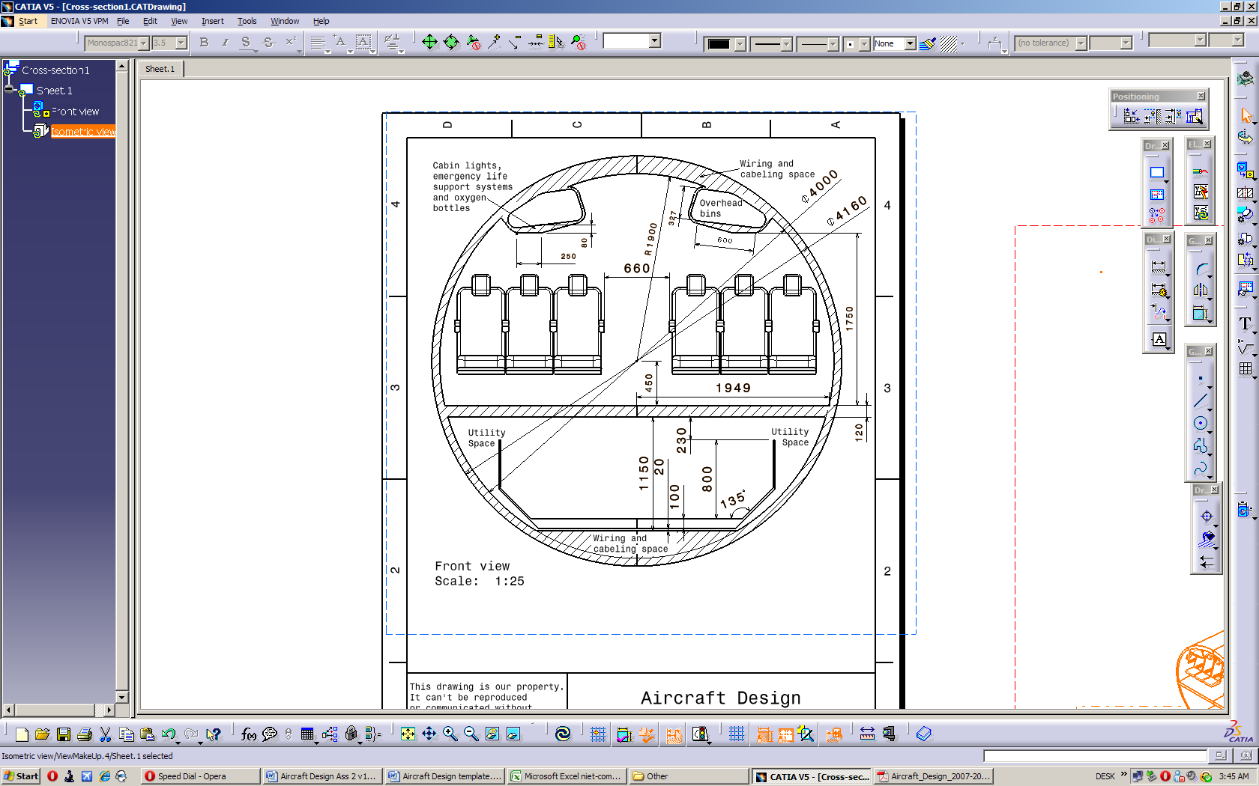

Table of Contents

1 – Introduction 4

2 -- Preliminary Sizing & Performance 5

2.1 – Fuel Fraction & Weight Estimation 5

2.2 – Sizing Graphs 5

3 -- Preliminary Engine Sizing 5

References: 6

Appendix 1: Additional Information 7

# 1 ­– Introduction

# 2 -- Preliminary Sizing & Performance

This section discusses the various components estimating fuel/payload weight and the bounds for propulsion and weight requirements/limits.

## 2.1 – Rapid Sizing For Aircraft Weight

This will include rough estimates for the weight of fuel in both types of flight sections and other weight factors to get a general estimate of the weight of the aircraft.

**2.1.1 – Non-Fuel Intensive Flight Section**

Using data from a table in Reference 1 of typical fuel consumption of business jets along with the equation for mass fuel fraction, the equation becomes:

$${M'}_{ff}=\frac{W_{1}}{W_{TO}}\prod_{i=1}^{i=n}{\frac{W_{i+1}}{W_{i}}=0.990*0.995*0.995*0.980*0.990*0.992=}0.94331$$

With the final answer being the fraction of weight left over after fuel has been used for these non-intensive phases (engine start & warmup, taxi on, take-off, climb, descent, landing, taxi off, and shutdown). This number can be used in subsequent sections to determine total fuel consumption.

**2.1.2 – Fuel Intensive Flight Section**

Equations for fuel consumption in this flight section become more particular to the aircraft due to determinations of range and flight speed. From the initial requirements, the range is 3600 km and the cruise speed is 830 km/hr (230.556 m/s). From the table of typical cruise data [Ref 1], there are ranges of L/D and cj values which can be used to calculate the weight fraction after cruising. Using average cruising values L/D = 11 and cj = 0.7 lbm/hr/lbf (19.829 mg/Ns), the equation becomes:

$${\left(\frac{W_{i}}{W_{i+1}}\right)}_{cruise}=e^{\frac{R}{{\left(\frac{V}{g*c_{j}}\right)}_{cruise}*{\left(\frac{L}{D}\right)}_{cruise}}}=e^{\frac{3600000}{\left(\frac{230.556}{9.80665*19.829*{10}^{-6}}\right)*11}}=1.317886$$

$${\left(\frac{W_{i+1}}{W_{i}}\right)}_{cruise}=0.758908$$

This number is the weight fraction left over specifically after the cruise phase. Next, the loitering phase will be calculated based on legal requirements for loiter endurance. There will be added sections for a second (lower) climb, loitering, and another descent covering an endurance of 45 minutes (2700 s). Using loiter values of L/D = 13 and cj = 0.5 lbm/hr/lbf (14.164 mg/Ns) the equation for this section is:

$${\left(\frac{W_{i}}{W_{i+1}}\right)}_{loiter}=e^{\frac{E}{{\left(\frac{1}{g*c_{j}}\right)}_{loiter}*{\left(\frac{L}{D}\right)}_{loiter}}}=e^{\frac{2700}{\frac{1}{9.80665*14.164*{10}^{-6}}*13}}=1.02927$$

$${\left(\frac{W_{i+1}}{W_{i}}\right)}_{loiter}=0.971564$$

**2.1.3 – Take-off Weight Estimation**

**2.1.4 – Total Weight Estimation**

## 2.2 – Sizing Graphs

# 3 -- Preliminary Engine Sizing

# References:

# Appendix 1: Additional Information